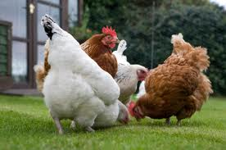
Interest in raising chickens has increased in recent years and many large and small municipalities provide regulations for “backyard” chickens. Douglas County allows for the raising of chickens in our neighborhood provided they are properly housed.

Reasons people enjoy raising chickens
- Eggs that are fresh and nutritious
- Environmentally friendly weed and bug control
- Provide great fertilizer
- Fun and friendly pets

Chicken coops and runs
- Provide indoor and outdoor living space for chickens
- Provide shelter from weather and predators
- Can be stationary or movable chicken “tractors”
- Each chicken requires approximately 2-4 ft² of inside space and 4-5 ft² of outside space

Potential community impact
- Noise- Hens are relatively quiet animals (roosters are forbidden)
- Smell- Waste is less than other already permitted animals and must be managed according to Douglas County Animal Waste and Odor Standards
- Sight- Structures must comply with current covenant regulations regarding construction and finish materials and with Douglas County setbacks

